**Assignment 11.1**

Perform the below operations:

a. Create a visual for representing missing values in the dataset.

Answer:

install.packages(“VIM”)

library(VIM)

bank_full_aggr = aggr(bank_full, col=mdc(1:2), numbers=TRUE, sortVars=TRUE, labels=names(bank_full), cex.axis=.7, gap=3, ylab=c("Proportion of missingness","Missingness Pattern"))

Variables sorted by number of missings:

Variable Count

age 0

job 0

marital 0

education 0

default 0

balance 0

housing 0

loan 0

contact 0

day 0

month 0

duration 0

campaign 0

pdays 0

previous 0

poutcome 0

y 0

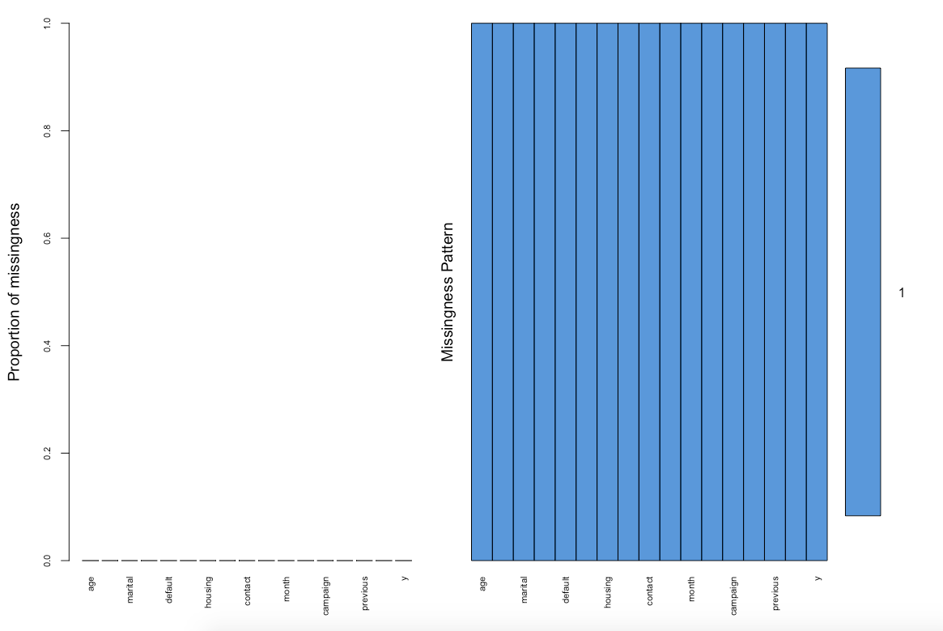

b. Show a distribution of clients based on a Job.

Answer:

job_data<-table(bank$job)

> job_data

admin. blue-collar entrepreneur housemaid management retired

478 946 168 112 969 230

self-employed services student technician unemployed unknown

183 417 84 768 128 38

> barplot(job_data, xlab = "Job", ylab = "Percentage", main = "Clients based on jobs")

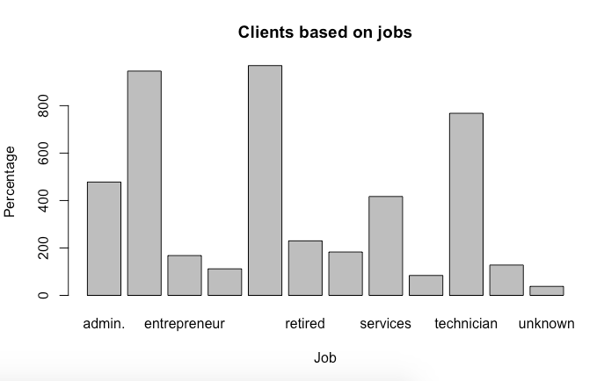

c. Check whether is there any relation between Job and Marital Status?

Answer:

install.packages(“gmodels”)

library(gmodels)

binddata<-CrossTable(job1, marital1, prop.chisq = FALSE)

Cell Contents

|-------------------------|

| N |

| N / Row Total |

| N / Col Total |

| N / Table Total |

|-------------------------|

Total Observations in Table: 4521

| marital1

job1 | divorced | married | single | Row Total |

--------------|-----------|-----------|-----------|-----------|

admin. | 69 | 266 | 143 | 478 |

| 0.144 | 0.556 | 0.299 | 0.106 |

| 0.131 | 0.095 | 0.120 | |

| 0.015 | 0.059 | 0.032 | |

--------------|-----------|-----------|-----------|-----------|

blue-collar | 79 | 693 | 174 | 946 |

| 0.084 | 0.733 | 0.184 | 0.209 |

| 0.150 | 0.248 | 0.145 | |

| 0.017 | 0.153 | 0.038 | |

--------------|-----------|-----------|-----------|-----------|

entrepreneur | 16 | 132 | 20 | 168 |

| 0.095 | 0.786 | 0.119 | 0.037 |

| 0.030 | 0.047 | 0.017 | |

| 0.004 | 0.029 | 0.004 | |

--------------|-----------|-----------|-----------|-----------|

housemaid | 13 | 84 | 15 | 112 |

| 0.116 | 0.750 | 0.134 | 0.025 |

| 0.025 | 0.030 | 0.013 | |

| 0.003 | 0.019 | 0.003 | |

--------------|-----------|-----------|-----------|-----------|

management | 119 | 557 | 293 | 969 |

| 0.123 | 0.575 | 0.302 | 0.214 |

| 0.225 | 0.199 | 0.245 | |

| 0.026 | 0.123 | 0.065 | |

--------------|-----------|-----------|-----------|-----------|

retired | 43 | 176 | 11 | 230 |

| 0.187 | 0.765 | 0.048 | 0.051 |

| 0.081 | 0.063 | 0.009 | |

| 0.010 | 0.039 | 0.002 | |

--------------|-----------|-----------|-----------|-----------|

self-employed | 15 | 127 | 41 | 183 |

| 0.082 | 0.694 | 0.224 | 0.040 |

| 0.028 | 0.045 | 0.034 | |

| 0.003 | 0.028 | 0.009 | |

--------------|-----------|-----------|-----------|-----------|

services | 62 | 236 | 119 | 417 |

| 0.149 | 0.566 | 0.285 | 0.092 |

| 0.117 | 0.084 | 0.099 | |

| 0.014 | 0.052 | 0.026 | |

--------------|-----------|-----------|-----------|-----------|

student | 0 | 10 | 74 | 84 |

| 0.000 | 0.119 | 0.881 | 0.019 |

| 0.000 | 0.004 | 0.062 | |

| 0.000 | 0.002 | 0.016 | |

--------------|-----------|-----------|-----------|-----------|

technician | 89 | 411 | 268 | 768 |

| 0.116 | 0.535 | 0.349 | 0.170 |

| 0.169 | 0.147 | 0.224 | |

| 0.020 | 0.091 | 0.059 | |

--------------|-----------|-----------|-----------|-----------|

unemployed | 22 | 75 | 31 | 128 |

| 0.172 | 0.586 | 0.242 | 0.028 |

| 0.042 | 0.027 | 0.026 | |

| 0.005 | 0.017 | 0.007 | |

--------------|-----------|-----------|-----------|-----------|

unknown | 1 | 30 | 7 | 38 |

| 0.026 | 0.789 | 0.184 | 0.008 |

| 0.002 | 0.011 | 0.006 | |

| 0.000 | 0.007 | 0.002 | |

--------------|-----------|-----------|-----------|-----------|

Column Total | 528 | 2797 | 1196 | 4521 |

| 0.117 | 0.619 | 0.265 | |

--------------|-----------|-----------|-----------|-----------|

barplot(binddata_counts, beside = TRUE, xlab = "Job", ylab = "Marital Status", main = "Relationship between JOB and MARITAL Status")

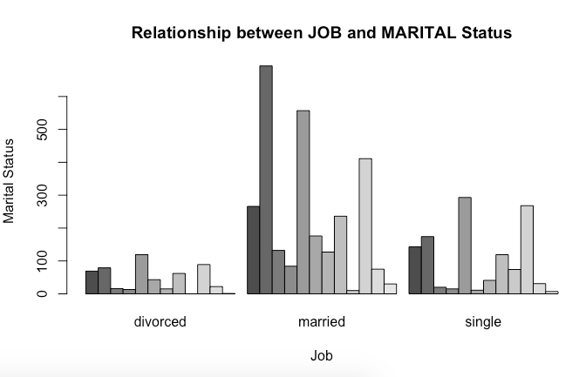

d. Check whether is there any association between Job and Education?

Answer: